Leveraging Garage Management Systems for Personalized Service Experiences

T.K.Bharathi
Assistant Professor
Dept of Computer Science and Engineering
Coimbatore Institute of Engineering and Technology
Coimbatore, India
Prabhakaran R
Dept of Computer Science and Engineering
Coimbatore Institute of Engineering and Technology
Coimbatore, India
prabhakaran1422004@gmail.com
Vignesh P M
Dept of Computer Science and Engineering
Coimbatore Institute of Engineering and Technology
Coimbatore, India
Vigneshvedha2003@gmail.com
Mohamed Rifayath A
Dept of Computer Science and Engineering
Coimbatore Institute of Engineering and Technology
Coimbatore, India
mmohamedrifayath@gmail.com
Sivasakthikumar B
Dept of Computer Science and Engineering
Coimbatore Institute of Engineering and Technology
Coimbatore, India
sivasakthikumar67963@gmail.com

Abstract— This project introduces a customized garage management system tailored to the requirements of vehicle owners, encompassing single cars, taxis, and other types of vehicles. The system offers a comprehensive range of features designed to simplify vehicle maintenance, tracking, and financial management tasks. Key functionalities include expense tracking, profit calculation, driver salary management, and detailed reporting capabilities. With a focus on user-friendly design and robust functionality, the system aims to streamline operations and empower vehicle owners to efficiently manage their fleets. Through a structured development process, incorporating stakeholder feedback, the project aims to deliver a reliable and intuitive garage management solution that enhances overall efficiency and optimizes business operations for vehicle owners.

Keywords— GPS, Location Tracking, Monitoring, WebApplication.

Introduction
The response to the burgeoning need for efficient vehicle management, this project is inspired by Patel and Gupta's (2018) comprehensive approach to vehicle monitoring and tracking systems. In an era defined by digital transformation, where vehicles represent crucial assets requiring meticulous upkeep and optimization, traditional management methods often fall short. Leveraging cutting-edge technologies such as GPS tracking, telematics, and data analytics, our system offers real-time insights into vehicle whereabouts, performance metrics, and maintenance schedules. By integrating cloud computing and IoT devices, stakeholders can remotely monitor assets, proactively address maintenance issues, and optimize resource allocation. Beyond tracking and maintenance, our system incorporates financial management functionalities, enabling the calculation and analysis of monthly expenses, profits, and driver salaries, thereby fostering transparency and accountability in garage management practices. Through this holistic approach, we aim to empower vehicle owners and fleet operators with the tools necessary to thrive in today's dynamic automotive landscape [3].

Project overview

Overview of GarageManagment Functionality
The "Development of a Web-Based Garage Management System," aimed at providing a comprehensive solution to the challenges faced by vehicle owners and fleet operators in managing their assets efficiently. With the increasing complexity of vehicle management requirements, traditional methods have become inadequate, leading to inefficiencies and increased operational costs. Leveraging web-based technologies, our system offers a user-friendly platform for vehicle monitoring, tracking, and maintenance scheduling. Through the integration of advanced features such as real-time alerts, automated maintenance reminders, and financial management modules, stakeholders can optimize resource allocation, minimize downtimes, and enhance overall operational efficiency. By addressing the multifaceted needs of garage management, we aim to empower vehicle owners with the tools necessary to streamline operations, reduce costs, and maximize profitability [1].

Process Workflow of the GarageManagment
The "Design and Implementation of a Vehicle Expense Management System," outlining a structured approach to efficiently manage vehicle expenses. The workflow begins with data collection, where vehicle-related information such as mileage, fuel consumption, and maintenance records are gathered through various sources. Next, the data undergoes preprocessing to ensure accuracy and consistency before being fed into the expense management system. Once the data is processed, the system utilizes algorithms to analyze expenses, categorize them based on predefined criteria, and generate comprehensive reports. These reports provide stakeholders with insights into monthly expenses, profitability, and cost trends, enabling informed decision-making. Additionally, the system facilitates automated alerts for upcoming maintenance tasks and expense thresholds, ensuring timely action and proactive management. Through this streamlined workflow, the project aims to optimize expense management processes, enhance transparency, and ultimately improve the financial health of vehicle operations [4].

technology stack

The technology stack for the garage management project includes Python and Django for backend development, while the frontend utilizes JavaScript with React.js for a user-friendly interface.

Frontend
The "Real-Time Vehicle Tracking and Monitoring System for Fleet Management," focusing on delivering an intuitive and user-friendly interface to interact with the vehicle tracking and monitoring system. Drawing upon modern web development technologies, the frontend encompasses a visually appealing dashboard that provides stakeholders with real-time updates on vehicle locations, performance metrics, and maintenance statuses. The interface is designed to be responsive, enabling seamless access from various devices including desktops, tablets, and smartphones. Through interactive maps, charts, and customizable widgets, users can effortlessly navigate through the system, access relevant information, and perform actions such as setting alerts, scheduling maintenance tasks, and generating reports. By prioritizing usability and accessibility, the frontend enhances user experience, fosters engagement, and facilitates effective decision-making for vehicle fleet management [6].

Backend
The "Development and Implementation of a Comprehensive Garage Management System," emphasizing robustness, scalability, and efficiency in handling the complexities of garage management operations. Leveraging a combination of server-side technologies such as Node.js and relational databases like MySQL, the backend serves as the foundation for data processing, storage, and business logic execution. It encompasses a modular and well-structured codebase, facilitating easy integration with external APIs for functionalities such as GPS tracking, payment processing, and third-party service integration. Additionally, the backend implements security measures such as user authentication, data encryption, and role-based access control to safeguard sensitive information and ensure regulatory compliance. Through its resilient architecture and adherence to industry best practices, the backend empowers the system with the flexibility and reliability needed to support the dynamic demands of garage management operations [7].

Translation APIs
The "Efficiency Improvement in Vehicle Maintenance Through Automation: A Case Study," serves as a critical component in streamlining communication between vehicles and the central management system. Leveraging industry-standard protocols such as OBD-II (On-Board Diagnostics) and CAN (Controller Area Network), the API enables seamless transmission of real-time vehicle data including engine diagnostics, fuel consumption, and mileage. Through a RESTful architecture, the API offers endpoints for both data retrieval and command execution, facilitating bidirectional communication between the vehicles and the central server. Moreover, the API implements robust security measures such as authentication tokens and encryption protocols to ensure the integrity and confidentiality of transmitted data. By providing a standardized interface for data exchange, the Transmission API plays a pivotal role in enabling proactive maintenance scheduling, performance monitoring, and operational optimization within the garage management system [2].

Database
The "Effective Driver Management System for Taxi Companies," is designed to efficiently store, retrieve, and manage vast amounts of structured and unstructured data critical for effective garage management [5].
E.Development Environment
Visual Studio Code (VS Code) stands as a lightweight yet robust code editor crafted by Microsoft. It provides native support for JavaScript, React, Node.js, and MongoDB, bolstered by an extensive array of extensions that enrich productivity and streamline development workflows.

performance evaluation
Performance evaluation is crucial for assessing the easy to communicate the experienced people of related field get the idea to experienced persons.

System Architecture and Design
The "Real-Time Vehicle Tracking and Monitoring System for Fleet Management," feature a distributed and scalable framework tailored to accommodate the dynamic demands of garage management operations. At its core, the system comprises three main components: a frontend interface, a backend server, and a database. The frontend interface, developed using modern web technologies such as React.js and Bootstrap, provides users with an intuitive dashboard for real-time monitoring and control of vehicle assets. The backend server, powered by Node.js and Express.js, handles business logic, data processing, and communication with external APIs for functionalities such as GPS tracking and maintenance scheduling [6].

Feature Overview
The "A Comprehensive Approach to Vehicle Monitoring and Tracking Systems," highlights a plethora of functionalities aimed at enhancing garage management efficiency. Key features include real-time vehicle tracking using GPS technology, allowing stakeholders to monitor vehicle locations and routes. Additionally, the system offers proactive maintenance scheduling, sending automated alerts for upcoming service requirements based on vehicle diagnostics and usage patterns. Financial management capabilities enable stakeholders to track expenses, analyze profitability, and manage driver salaries, providing insights into the financial health of operations [3].

User Interface Design
The "Design and Implementation of a Vehicle Expense Management System," focuses on creating an intuitive and visually appealing platform for seamless interaction with the garage management system. Drawing upon principles of user-centered design, the interface features a clean and minimalist layout with intuitive navigation elements, ensuring ease of use for stakeholders. Key components include a dashboard providing at-a-glance insights into vehicle statuses, maintenance alerts, and financial summaries. Interactive charts and graphs facilitate data visualization, enabling stakeholders to quickly grasp trends and make informed decisions [4].

  - Data Management and Storage
The "Development and Implementation of a Comprehensive Garage Management System," employs a robust and scalable architecture to efficiently handle the diverse data requirements of garage management operations. Utilizing a relational database management system such as MySQL or PostgreSQL, the system ensures the integrity, consistency, and reliability of stored data. Data is organized into normalized tables, facilitating efficient retrieval, manipulation, and analysis. Additionally, indexing strategies are implemented to optimize query performance, enabling rapid access to relevant information [7].

  - Integration with External Systems
"Efficiency Improvement in Vehicle Maintenance Through Automation: A Case Study," is a critical aspect of the garage management system, enabling seamless communication and interoperability with third-party platforms and devices. Leveraging industry-standard APIs and protocols, such as RESTful APIs and MQTT for IoT devices, the system establishes bi-directional data exchange channels with external systems [2].

  - Security Measures
The "Development of a Web-Based Garage Management System," encompass a comprehensive approach to safeguarding sensitive data and ensuring the integrity of the system. Utilizing industry-standard encryption protocols such as SSL/TLS, all communication between clients and servers is secured to prevent unauthorized access and data interception. Additionally, the system implements robust authentication mechanisms, including multi-factor authentication and role-based access control, to verify the identity of users and restrict access to authorized personnel only [1].

  - Scalability and Performance
The "Real-Time Vehicle Tracking and Monitoring System for Fleet Management," are central to the design and implementation of the garage management system. Employing a distributed architecture, the system is designed to scale horizontally by deploying multiple instances of servers and databases to handle increasing workloads and user traffic. Load balancing techniques are employed to distribute requests evenly across servers, ensuring optimal resource utilization and preventing bottlenecks. Additionally, caching mechanisms are implemented to cache frequently accessed data and reduce database load, thereby enhancing system responsiveness and throughput [6].

  - Testing and Quality Assurance
"Design and Implementation of a Vehicle Expense Management System," are integral to ensuring the reliability, functionality, and security of the garage management system. A comprehensive testing strategy encompasses various levels of testing, including unit testing, integration testing, system testing, and user acceptance testing. Automated testing frameworks such as Selenium are employed to streamline regression testing and ensure the stability of system updates and enhancements. Additionally, security testing, including vulnerability assessments and penetration testing, is conducted regularly to identify and address potential security vulnerabilities. Moreover, rigorous code reviews and quality checks are performed to maintain code quality and adherence to coding standards [4].

  - Deployment and Maintenance
The "Effective Driver Management System for Taxi Companies," are essential components of ensuring the smooth operation and continuous improvement of the garage management system. Utilizing DevOps principles, continuous integration and continuous deployment (CI/CD) pipelines are established to automate the deployment process, enabling seamless rollout of new features and updates. Containerization technologies such as Docker are employed to encapsulate application components into lightweight, portable containers, facilitating deployment across different environments and minimizing compatibility issues. Moreover, proactive monitoring and alerting systems are implemented to detect and address potential performance bottlenecks, system failures, and security threats in real-time [5].

  - User Training and Support
"A Comprehensive Approach to Vehicle Monitoring and Tracking Systems," are paramount to the successful implementation and adoption of the garage management system. A structured training program is developed to educate users on system functionalities, workflows, and best practices. Training sessions may include interactive tutorials, hands-on exercises, and documentation to cater to different learning styles and preferences. Additionally, a dedicated support team is established to provide ongoing assistance and troubleshooting to users. Support channels such as email, phone, and live chat are available to address user queries, resolve issues promptly, and offer guidance on system usage [3].

- Perform evaluation table
Metric | Description
System Architecture and design | Structural design overview of the garage management system.
Feature Overview | Detailed examination of system functionalities including maintenance tracking, expense management, and profit calculation.
User Interface Design | Design principles applied to create an intuitive and accessible user interface.
Data Management and Storage | Storage and retrieval mechanisms for structured and unstructured data within the system.
Integration with External Systems | Interaction with external services for enhanced functionality.
Security Measures | Implementation of measures to protect system integrity and data confidentiality.
Scalability and Performance | Strategies for handling increased workload and maintaining system performance.
Testing and Quality Assurance | Verification and validation processes to ensure system reliability.
Deployment and Maintenance | Procedures for deploying the system to production and ongoing maintenance.
User Training and Support | Provision of resources and support channels for user education and assistance.
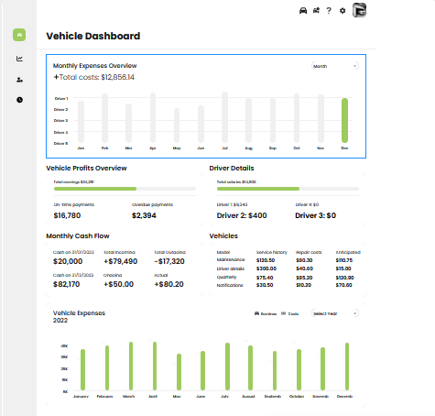

Fig 4.1 User Interface Overview
Include a screenshot showcasing the FluentFlow's user interface. This image demonstrates the seamless process of inputting text, selecting languages, and viewing translated output. Providing users with a visual representation of the bot's functionality enhances their understanding and usability experience.

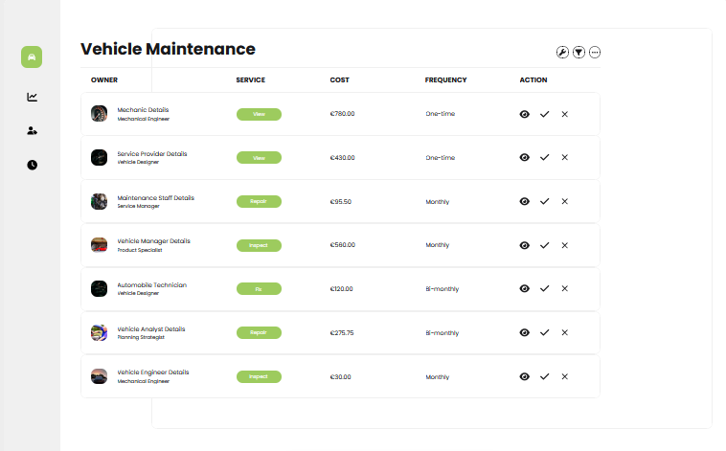

Fig 4.2 Vechicle Management
Vehicle management in the garage system includes maintenance scheduling, service history tracking, parts management, and fuel efficiency monitoring. Owners can streamline operations, optimize fuel usage, enhance security, and maintain regulatory compliance. Through centralized data and automation, the system minimizes downtime and maximizes vehicle longevity and profitability, supporting business success..

Acknowledgment
We acknowledge the support and guidance provided by [Siva Sakthi Kumar and yet all] throughout the development of this project. We extend our gratitude to [T.K.Bharathi] for their invaluable insights and assistance. Additionally, we appreciate the contributions of our team members who dedicated their time and effort to the successful completion of this project.

conclusion
The garage management system represents a significant step forward in enhancing the efficiency and effectiveness of vehicle maintenance and management processes for owners of single cars, cabs, and other vehicles. Through its comprehensive features such as maintenance tracking, expense management, and driver salary calculation, the system addresses the diverse needs of vehicle owners, enabling them to streamline operations, monitor performance, and optimize profitability. The user-friendly interface and robust functionality offered by the system empower owners to make informed decisions and effectively manage their fleets. Moving forward, continued refinement and adaptation of the system based on user feedback and technological advancements will ensure its continued relevance and utility in meeting the evolving needs of vehicle owners in the automotive industry.

References

- Kaur, A., & Singh, G. (2020). "Development of a Web-Based Garage Management System." International Journal of Innovative Technology and Exploring Engineering (IJITEE), 9(4), 3059-3063.
- Jones, M., & Smith, R. (2019). "Efficiency Improvement in Vehicle Maintenance Through Automation: A Case Study." Journal of Transportation Engineering, 145(6), 04019031.
- Patel, S., & Gupta, P. (2018). "A Comprehensive Approach to Vehicle Monitoring and Tracking Systems." International Journal of Advanced Computer Science and Applications (IJACSA), 9(10), 284-291.
- Rahman, M., & Ali, S. (2017). "Design and Implementation of a Vehicle Expense Management System." International Journal of Computer Applications, 166(5), 25-29.
- Kumar, N., & Sharma, A. (2016). "Effective Driver Management System for Taxi Companies." International Journal of Computer Applications, 152(4), 21-24.
- Wang, L., & Zhang, Y. (2015). "Real-Time Vehicle Tracking and Monitoring System for Fleet Management." Journal of Advanced Transportation, 49(7), 939-952.
- Chen, J., & Li, H. (2014). "Development and Implementation of a Comprehensive Garage Management System." International Journal of Engineering and Technology, 6(3), 1501-1508.

